

Al-Yamamah University

College of Engineering and Architecture

Department of Software Engineering

Sneaker Store

Prepared by:

(Mohamemd Sawan) (202311222)

CIS 201 Fundamentals of Web Design

(Ms.Sara Alsabeg)

Table of Contents

Introduction………………………………………3

Page layout……………………………………3

Page Hierarchy ……………………………………4

Home page………………………………………4

Products page……………………………………5

Cart page…………………………………………5

About me page……………………………………6

External links……………………………………7

Introduction

My project is a Sneaker Store that offers different types of sneakers. It has a Home Page, Products Page , a Cart , and a About me page

Pages layout

Color Scheme:

|  |  |  |
| --- | --- | --- |
| color | Hexadecimal Value | Used for |
|  | **#000000 & #FFFFFF** | Font |
|  | **#007bff & #dc3545** | button |
|  | **#FFFFFF & #000000** | Header |
|  | **#333** | Footer |

There are no fonts used in the pages

Page Hierarchy:

AboutMe.html

Products.html

Cart.html

Home.html

**Home Page:**

Includes a header, footer, navigation buttons and a 2 buttons with pictures that takes you to the products and the about me page.

Products page:

It has a few sneakers listed with their prices and a button that adds that sneaker to the cart

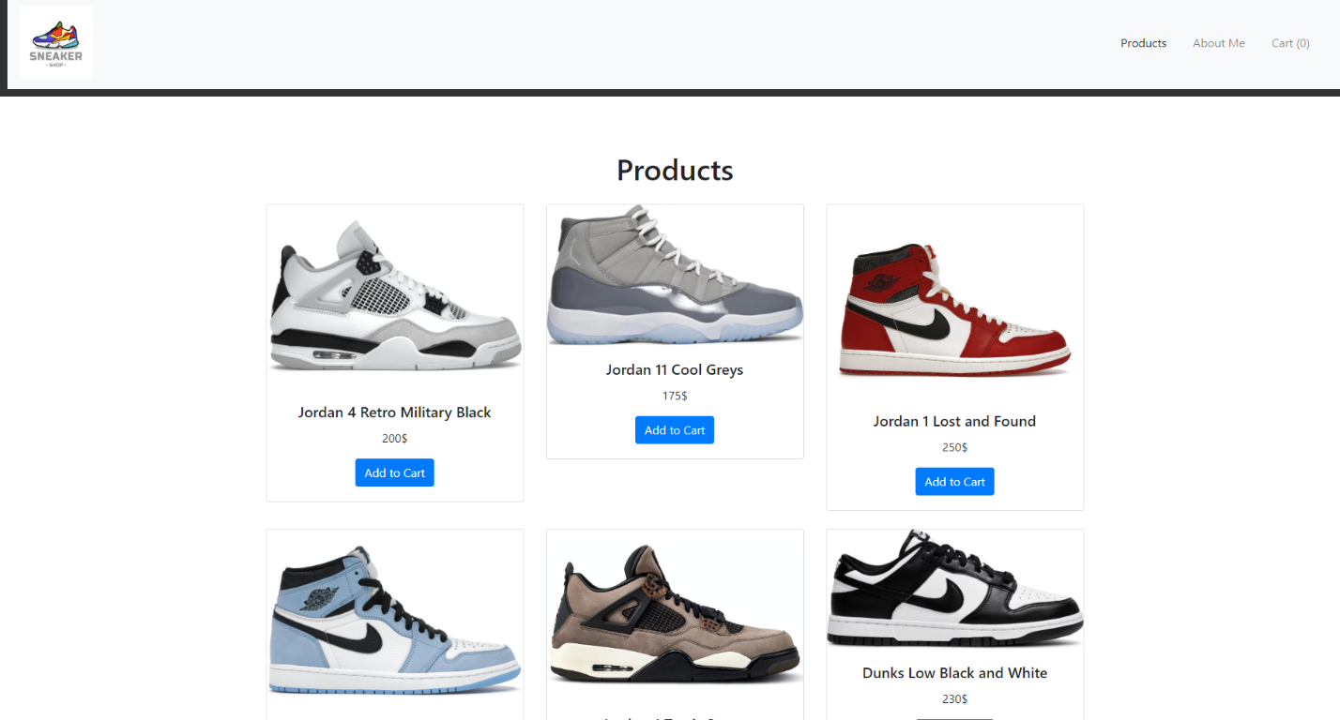

Cart page:

In the cart page you can find the items u added from the products page and it has a calculator that give you your total

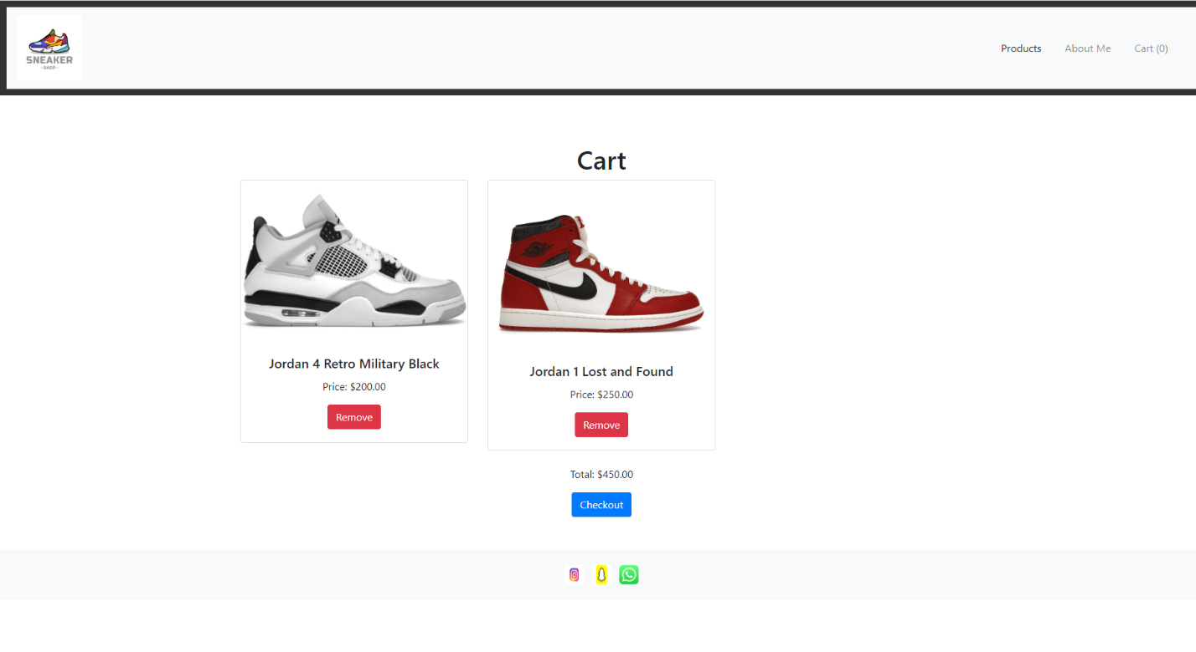

About me page:

The about me page has a button that takes u back to the home page plus information about myself



External links:

Bootstrap:

<script src="https://code.jquery.com/jquery-3.5.1.slim.min.js"></script>

    <script src="https://stackpath.bootstrapcdn.com/bootstrap/4.5.2/js/bootstrap.min.js"></script>

<link href="https://stackpath.bootstrapcdn.com/bootstrap/4.5.2/css/bootstrap.min.css" rel="stylesheet">

For css:

<script src="script.js" defer></script>

For JS:

<script src="cartScript.js" defer></script> for the cart calculator and remove button

<script src="script.js" defer></script> to connect the product and cart pages